第11章 MATLAB图形用户界面设计
3．建立控件对象举例
（1）建立按钮和双位按钮
程序如下：
pbstart=uicontrol(gcf,'Style','push','Position',...
[50,5,60,25],'String','Start Plot',...
'CallBack','t=-pi:pi/20:pi;plot(t,sin(t))');
ptgrid=uicontrol(gcf,'Style','toggle','Position',...
[150,5,60,25],'String','Grid','CallBack','grid');

（2）建立单选按钮
程序如下：
set(gcf,'Color','R') %设置默认的背景颜色
htxt=uicontrol(gcf,'Style','text','String',...
'Color Options','Position',[200,130,150,20]);
%建立单选按钮
hr=uicontrol(gcf,'Style','radio','String',...
'Red','Position',[200,100,150,25],'Value',1,...
'CallBack',['set(hr,''Value'',1);','set(hb,''Value'',0);',...
'set(hy,''Value'',0);','set(gcf,''Color'',''R'')']);
hb=uicontrol(gcf,'Style','radio','String',...
'Blue','Position',[200,75,150,25],...
'CallBack',['set(hb,''Value'',1),','set(hr,''Value'',0);',...
'set(hy,''Value'',0);','set(gcf,''Color'',''B'')']);
hy=uicontrol(gcf,'Style','radio','String',...
'Yellow','Position',[200,50,150,25],...
'CallBack',['set(hy,''Value'',1),','set(hr,''Value'',0);',...
'set(hb,''Value'',0);','set(gcf,''Color'',''Y'')']);

（3）建立复选框
程序如下：
htxt=uicontrol(gcf,'Style','text','Position',[200,125,150,25],...
'String','Set Windows Properties');
hp=uicontrol(gcf,'Style','check','Position',...
[200,100,150,25],'String','MyPosition',...
'CallBack',['set(gcf,''Position'',[10,10,300,250]);',...
'if get(hp,''Value'')==1,',...
'set(gcf,''Position'',[10,10,600,500]),','end']);
hc=uicontrol(gcf,'Style','check','Position',...
[200,75,150,25],'String','MyColor',...
'CallBack',['set(gcf,''color'',''w'');',...
'if get(hc,''Value'') ==1,','set(gcf,''color'',''g''),','end']);
hn=uicontrol(gcf,'Style','check','Position',...
[200,50,150,25],'String','MyName',...
'CallBack',['set(gcf,''Name'',''复选框未选中'');',...
'if get(hn,''Value'') ==1,',...
'set(gcf,''Name'',''复选框被选中''),','end']);

（4）建立弹出框
程序如下：
hpop=uicontrol(gcf,'Style','popup','String',...
'red|blue|green|yellow|white','Position',[100,100,100,80],...
'CallBack',['cbcol=[''R'',''B'',''G'',''Y''];',...
'set(gcf,''Color'',cbcol(get(hpop,''Value'')))']);

（5）建立列表框
界面中列表框的作用与（4）同，程序如下：
hl=uicontrol(gcf,'Style','list',...
'String','red|blue|green|yellow|white',...
'Position',[100,100,100,80],'CallBack',...
['cbcol=[''r'',''b'',''g'',''y'',''w'',''k''];',...
'set(gcf,''color'',cbcol(get(hl,''value'')));']);

（6）建立编辑框及边框
程序如下：
ftdir=uicontrol(gcf,'Style','frame',...
'back','y','Position',[30,180,120,100]);
edmulti=uicontrol(gcf,'Style','edit',...
'String','MATLAB is a very useful language.',...
'Position',[50,200,75,55],'Max',2,'back','w');

（7）建立滑动条
程序如下：
fig=figure('Position',[20,20,400,150]);
hsli1=uicontrol(fig,'Style','slider','Position',...
[50,50,120,20],'Min',200,'Max',800,'Value',400,...
'CallBack',['set(azmcur,''String'','...
'num2str(get(hsli1,''Value'')));'...
'set(gcf,''Position'',[20,20,get(hsli1,''Value''),300]);']);
hsli2=uicontrol(fig,'Style','slider','Position',...
[240,50,120,20],'Min',100,'Max',600,'Value',300,...
'CallBack',['set(elvcur,''String'','...
'num2str(get(hsli2,''Value'')));',...
'set(gcf,''Position'',[20,20,400,get(hsli2,''Value'');])']);
%用静态文本标出最小值
azmmin=uicontrol(fig,'Style','text','Position',...
[20,50,30,20],'String',num2str(get(hsli1,'Min')));
elvmin=uicontrol(fig,'Style','text','Position',...
[210,50,30,20],'String',num2str(get(hsli2,'Min')));
%用静态文本标出最大值
azmmax=uicontrol(fig,'Style','text','Position',...
[170,50,30,20],'String',num2str(get(hsli1,'Max')));
elvmax=uicontrol(fig,'Style','text','Position',...
[360,50,30,20],'String',num2str(get(hsli2,'Max')));
%用静态文本标出当前设置的宽度和高度
azmLabel=uicontrol(fig,'Style','text','Position',...
[50,80,65,20],'String','Width');
elvLabel=uicontrol(fig,'Style','text','Position',...
[240,80,65,20],'String','Height');
azmcur=uicontrol(fig,'Style','text','Position',...
[120,80,50,20],'String',num2str(get(hsli1,'Value')));
elvcur=uicontrol(fig,'Style','text','Position',...
[310,80,50,20],'String',num2str(get(hsli2,'Value')));

例11-1 建立如图11-8所示的数制转换对话框，在左边输入一个十进制整数和2～16之间的数，单击“转换”按钮能在右边得到十进制数所对应的2～16进制字符串，单击“退出”按钮退出对话框。
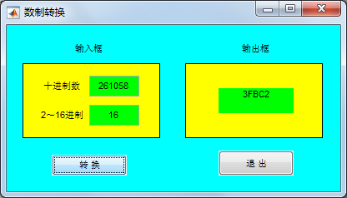
图11-8 数制转换对话框
程序如下：
hf=figure('Color',[0,1,1],'Position',[100,200,400,200],...
'Name','数制转换','NumberTitle','off','MenuBar','none');
uicontrol(hf,'Style','Text','Position',[80,160,40,20],...
'Horizontal','center','String','输入框','Back',[0,1,1])
uicontrol(hf,'Style','Text','Position',[280,160,40,20],...
'Horizontal','center','String','输出框','Back',[0,1,1])
uicontrol(hf,'Style','Frame','Position',[20,65,165,90],'Back',[1,1,0])
uicontrol(hf,'Style','Text','Position',[25,110,85,25],...
'Horizontal','center','String','十进制数','Back',[1,1,0])
uicontrol(hf,'Style','Text','Position',[25,75,85,25],...
'Horizontal','center','String','2～16进制','Back',[1,1,0])
he1=uicontrol(hf,'Style','Edit','Position',[100,115,60,25],...
'Back',[0,1,0]);
he2=uicontrol(hf,'Style','Edit','Position',[100,80,60,25],...
'Back',[0,1,0]);
uicontrol(hf,'Style','Frame','Position',[215,65,165,90],'Back',[1,1,0])
ht=uicontrol(hf,'Style','Text','Position',[255,95,90,30],...
'Horizontal','center','Back',[0,1,0]);
COMM=['n=str2num(get(he1,''String''));',...
'b=str2num(get(he2,''String''));',...
'dec=trdec(n,b);','set(ht,''string'',dec);'];
uicontrol(hf,'Style','Push','Position',[55,20,90,25],...
'String','转 换','Call',COMM)
uicontrol(hf,'Style','Push','Position',[255,20,90,30],...
'String','退 出','Call','close(hf)')
程序调用了trdec.m函数文件，该函数的作用是将任意十进制整数转换为2~16进制字符串。trdec.m函数文件如下：
function dec=trdec(n,b)
ch1='0123456789ABCDEF'; %十六进制的16个符号
k=1;
while n~=0 %不断除某进制基数取余直到商为0
p(k)=rem(n,b);
n=fix(n/b);
k=k+1;
end
k=k-1;
strdec='';
while k>=1 %形成某进制数的字符串
kb=p(k);
strdec=strcat(strdec,ch1(kb+1:kb+1));
k=k-1;
end
dec=strdec;

例11-2 建立如图11-9所示的图形演示对话框，在编辑框中输入绘图命令，当单击“绘图”按钮时，能在左边坐标轴绘制出所对应的图形，弹出框提供色图控制，列表框提供坐标网格线和坐标边框控制。
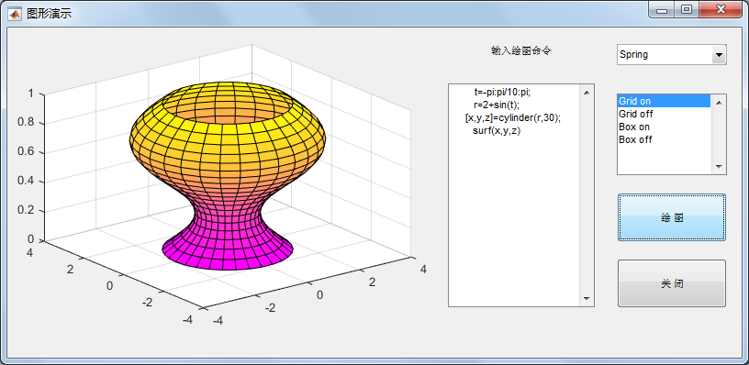
图11-9 图形演示对话框
程序如下：
clf
set(gcf,'Unit','normalized','Position',[0.2,0.3,0.5,0.40])
set(gcf,'Menubar','none','Name','图形演示','NumberTitle','off')
axes('Position',[0.05,0.15,0.5,0.8])
uicontrol(gcf,'Style','text', 'Unit','normalized',...
'Posi',[0.60,0.85,0.2,0.1],'String',...
'输入绘图命令','Horizontal','center')
hedit=uicontrol(gcf,'Style','edit','Unit','normalized',...
'Posi',[0.60,0.15,0.2,0.68],...
'Max',2); %Max取2，使Max-Min>1，从而允许多行输入
hpopup=uicontrol(gcf,'Style','popup','Unit','normalized',...
'Posi',[0.83,0.8,0.15,0.15],'String',...
'Spring|Summer|Autumn|Winter','Call',...
'comm(hedit,hpopup,hlist)');
hlist=uicontrol(gcf,'Style','list','Unit','normalized',...
'Posi',[0.83,0.55,0.15,0.25],'String',...
'Grid on|Grid off|Box on|Box off','Call',...
'comm(hedit,hpopup,hlist)');
hpush1=uicontrol(gcf,'Style','push','Unit','normalized',...
'Posi',[0.83,0.35,0.15,0.15],'String',...
'绘 图','Call','comm(hedit,hpopup,hlist)');
uicontrol(gcf,'Style','push','Unit','normalized',...
'Posi',[0.83,0.15,0.15,0.15],'String',...
'关 闭','Call','close all')
程序调用了comm.m函数文件，其定义如下：
function comm(hedit,hpopup,hlist)
com=get(hedit,'String');
n1=get(hpopup,'Value');
n2=get(hlist,'Value');
if ~isempty(com) %编辑框输入非空时
eval(com'); %执行从编辑框输入的命令
chpop={'spring','summer','autumn','winter'};
chlist={'grid on','grid off','box on','box off'};
colormap(eval(chpop{n1}));
eval(chlist{n2});
end

例11-3 建立图形演示系统，系统菜单条中含有3个菜单项：Plot、Option和Quit。Plot中有Sine Wave和Cosine Wave两个子菜单项，分别控制在本图形窗口画出正弦和余弦曲线。Option菜单项的内容如图11-10所示，其中Grid on和Grid off控制给坐标轴加网格线，Box on和Box off控制给坐标轴加边框，而且这4项只有在画有曲线时才是可选的。Window Color控制图形窗口背景颜色。Quit控制是否退出系统。
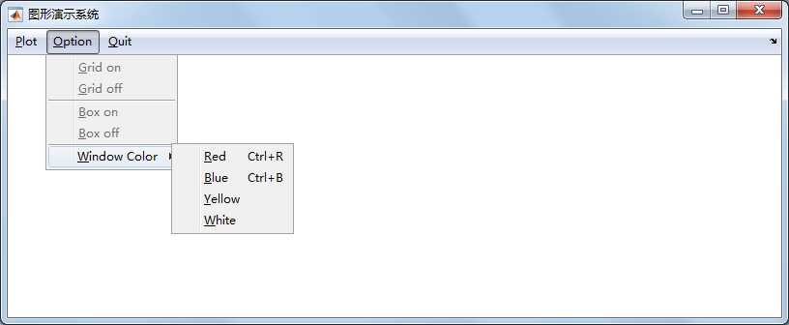
图11-10 图形演示系统菜单
程序如下：
screen=get(0,'ScreenSize');
W=screen(3);
H=screen(4);
figure('Color',[1,1,1],'Position',[0.2*H,0.2*H,0.5*W,0.3*H],...
'Name','图形演示系统','NumberTitle','off','MenuBar','none')
%定义Plot菜单项
hplot=uimenu(gcf,'Label','&Plot');
uimenu(hplot,'Label','Sine Wave','Call',...
['t=-pi:pi/20:pi;','plot(t,sin(t));',...
'set(hgon,''Enable'',''on'');',...
'set(hgoff,''Enable'',''on'');',...
'set(hbon,''Enable'',''on'');',...
'set(hboff,''Enable'',''on'')'])
uimenu(hplot,'Label','Cosine Wave','Call',...
['t=-pi:pi/20:pi;','plot(t,cos(t));',...
'set(hgon,''Enable'',''on'');',...
'set(hgoff,''Enable'',''on'');',...
'set(hbon,''Enable'',''on'');',...
'set(hboff,''Enable'',''on'')'])
%定义Option菜单项
hoption=uimenu(gcf,'Label','&Option');
hgon=uimenu(hoption,'Label','&Grid on',...
'Call','grid on','Enable','off');
hgoff=uimenu(hoption,'Label','&Grid off',...
'Call','grid off','Enable','off');
hbon=uimenu(hoption,'Label','&Box on',...
'separator','on','Call','box on','Enable','off');
hboff=uimenu(hoption,'Label','&Box off',...
'Call','box off','Enable','off');
hwincor=uimenu(hoption,'Label','&Window Color','Separator','on');
uimenu(hwincor,'Label','&Red','Accelerator','r',...
'Call','set(gcf,''Color'',''r'')')
uimenu(hwincor,'Label','&Blue','Accelerator','b',...
'Call','set(gcf,''Color'',''b'')')
uimenu(hwincor,'Label','&Yellow','Call',...
'set(gcf,''Color'',''y'')')
uimenu(hwincor,'Label','&White','Call',...
'set(gcf,''Color'',''w'')')
%定义Quit菜单项
uimenu(gcf,'Label','&Quit','Call','close(gcf)')

例11-4 绘制曲线y=2e^{-0.5x}sin(2πx)，并建立一个与之相联系的快捷菜单，用以控制曲线的线型和曲线宽度。
程序如下：
x=0:pi/100:2*pi;
y=2*exp(-0.5*x).*sin(2*pi*x);
hl=plot(x,y);
hc=uicontextmenu; %建立快捷菜单
hls=uimenu(hc,'Label','线型'); %建立菜单项
hlw=uimenu(hc,'Label','线宽');
uimenu(hls,'Label','虚线','Call','set(hl,''LineStyle'','':'');')
uimenu(hls,'Label','实线','Call','set(hl,''LineStyle'',''-'');')
uimenu(hlw,'Label','加宽','Call','set(hl,''LineWidth'',2);')
uimenu(hlw,'Label','变细','Call','set(hl,''LineWidth'',0.5);')
set(hl,'UIContextMenu',hc) %将该快捷菜单和曲线对象联系起来

例11-5 利用图形用户界面设计工具设计如图11-22所示的用户界面。该界面包括一个用于显示图形的轴对象，显示的图形包括表面图、网格图或等高线图。绘制图形的功能通过3个命令按钮来实现，用户通过单击相应的按钮，即可绘制相应图形。绘制图形所需要的数据通过一个弹出框来选取。在弹出框中包括3个选项，分别对应MATLAB的数据函数Peaks、Membrane和用户自定义的绘图数据Sinc，用户可以通过选择相应的选项来载入相应的绘图数据。
（a）为打开图形窗口事件编写响应代码。选择MATLAB编辑器的“编辑器”选项卡，在“导航”命令组中单击“转至”命令按钮，在弹出的菜单中选择guidemo_OpeningFcn函数，在以%varargin开头的注解语句下输入以下代码：
handles.peaks=peaks(35);
handles.membrane=membrane;
[x,y]=meshgrid(-8:0.3:8);
r=sqrt(x.^2+y.^2);
sinc=sin(r)./(r+eps);
handles.sinc=sinc;
handles.current_data=handles.sinc;
surf(handles.current_data)
（b）为列表框编写响应代码。选择ChooseFun_Callback函数，在以%handles开头的注解语句下输入以下代码：
str=get(hObject,'String');
val=get(hObject,'Value');
%设置用所选函数产生当前数据集
switch str{val}
case 'Peaks'
handles.current_data=handles.peaks;
case 'Membrane'
handles.current_data=handles.membrane;
case 'Sinc'
handles.current_data=handles.sinc;
end
% 保存句柄结构
guidata(hObject,handles)

例11-6 在例11-5的图形窗口中添加图形窗口的默认菜单和一个自定义菜单项“设置”。“设置”菜单项的内容如图11-23所示，其中“网格线”控制给坐标轴加网格线，“边框”控制给坐标轴加边框，“背景色”控制图形窗口的背景颜色。
（a）为“网格线”菜单项编写响应代码。选择hgon_Callback函数，在以%handles开头的注解语句下输入以下代码：
if strcmp(get(gcbo,'Checked'),'on')
set(gcbo,'Checked','off')
grid off
else
set(gcbo,'Checked','on')
grid on
end
（b）为“边框”菜单项编写响应代码。选择hbon_Callback函数，在该区添加以下代码：
if strcmp(get(gcbo,'Checked'),'on')
set(gcbo,'Checked','off')
box off
else
set(gcbo,'Checked','on')
box on
end
（c）为3个颜色菜单项编写响应代码。选择hwcYellow_Callback函数，在该区添加以下代码：
set(gcbf,'Color','y')
set(gcbo,'Checked','on')
set(handles.hwcBlue,'Checked','off')
set(handles.hwcWhite,'Checked','off')
选择hwcBlue_Callback函数，在该区添加以下代码：
set(gcbf,'Color','b')
set(gcbo,'Checked','on')
set(handles.hwcYellow,'Checked','off')
set(handles.hwcWhite,'Checked','off')
选择hwcWhite_Callback函数，在该区添加以下代码：
set(gcbf,'Color','w')
set(gcbo,'Checked','on')
set(handles.hwcYellow,'Checked','off')
set(handles.hwcBlue,'Checked','off')

